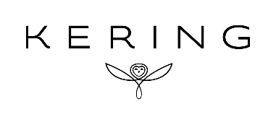

Kering
Société anonyme with a share capital of €493,683,112
Head office: 40, rue de Sèvres – 75007 PARIS
552 075 020 RCS PARIS

April 16, 2024

Monthly statement
on the total number of shares and voting rights
(articles L.233-8 of the French Commercial Code and 223-16 of the General Regulation of the French Financial Markets Authority (AMF – Autorité des Marchés Financiers)

Date | Total number of  shares | Total number of voting rights
 |  | theoretical ¹ | exercisable ²
April 15, 2024 | 123,420,778 | 176,620,857 | 175,786,710

¹ Calculated based on all shares with voting rights, including treasury shares stripped of voting rights (Art. 223-11 of AMF General Regulation).

² Excluding treasury shares stripped of voting rights.

